|  |
| --- |
| Web Master .inc |
| The Midnight Meat Train |
| Document |
| Version #1.0  All work Copyright © 2016 by WebMaster .Inc.  All rights reserved. |
| Duc Minh Tran |
|  |

|  |
| --- |
| May 16th 2012 |

Table of Contents

1. Game Overview 4

2. Game Play Mechanics 5

3. Camera 6

4. Controls 6

5. Saving and Loading 6

6. Interface Sketch 6

7. Menu and Screen Descriptions 7

8. Game World 7

9. Levels 7

10. Characters 7

11. Non-player Characters 7

12. Enemies 7

13. Weapons 8

14. Items 8

15. Abilities 8

16. Vehicles 8

17. Script 8

18. Scoring 8

19. Puzzles/Mini-games 8

20. Bonuses 8

21. Cheat Codes 8

22. Art / Multimedia Index 8

23. Design Notes 9

24. Future Features 9

Version History

* Version 1.0: Initial Commit (Feb 2, 2016)
* Version 1.1: First Outcome Completed (Feb 2, 2016)
* Version 1.2: Second Decision Tree in progress (Feb 2, 2016)
* Version 1.3: Decision B GUI fixed (Feb 2, 2016)
* Version 1.4: Happy Path Finished (Feb 3, 2016)
* Version 1.5: fix BMG init (Feb 3, 2016)
* Version 2.0: Un-formatted Code (Feb 4, 2016)
* Version 2.1: Internal Document - In progress (Feb 4, 2016)
* Version 2.2 Internal Document - In progress (Feb 4, 2016)
* Version 2.3: Internal Document - Completed (Feb 4, 2016)
* Version 2.4: Adding Sound Effect (Feb 4, 2016)

# Game Overview

The game based on a movie – The Midnight Meat Train (Directed by Ryûhei Kitamura). The main story has been modified to match the requirement of assignment 1.

Players have to make their choices wisely, thinking they are the main character in order to win the game.

# Game Play Mechanics

Player will be prompted to select 2 or multiple decisions level while playing the game. There are options to go back in the non-decision scene. One user go through a decision, they will not be able to go back.

Here is the game decision model

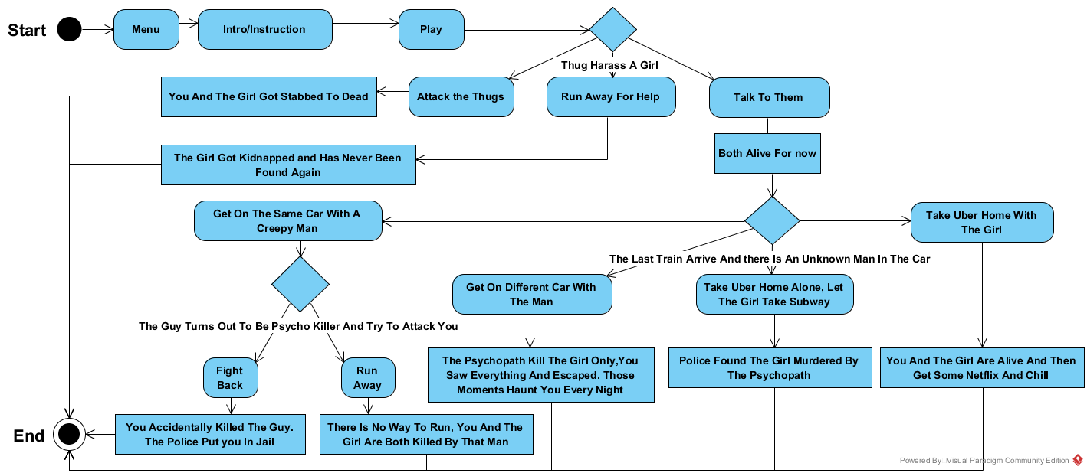

# Camera

The point of view is user’s sight – in front of the scene

# Controls

User can control this game by using mouse and click on buttons.

# Saving and Loading

N/A

# Interface Sketch

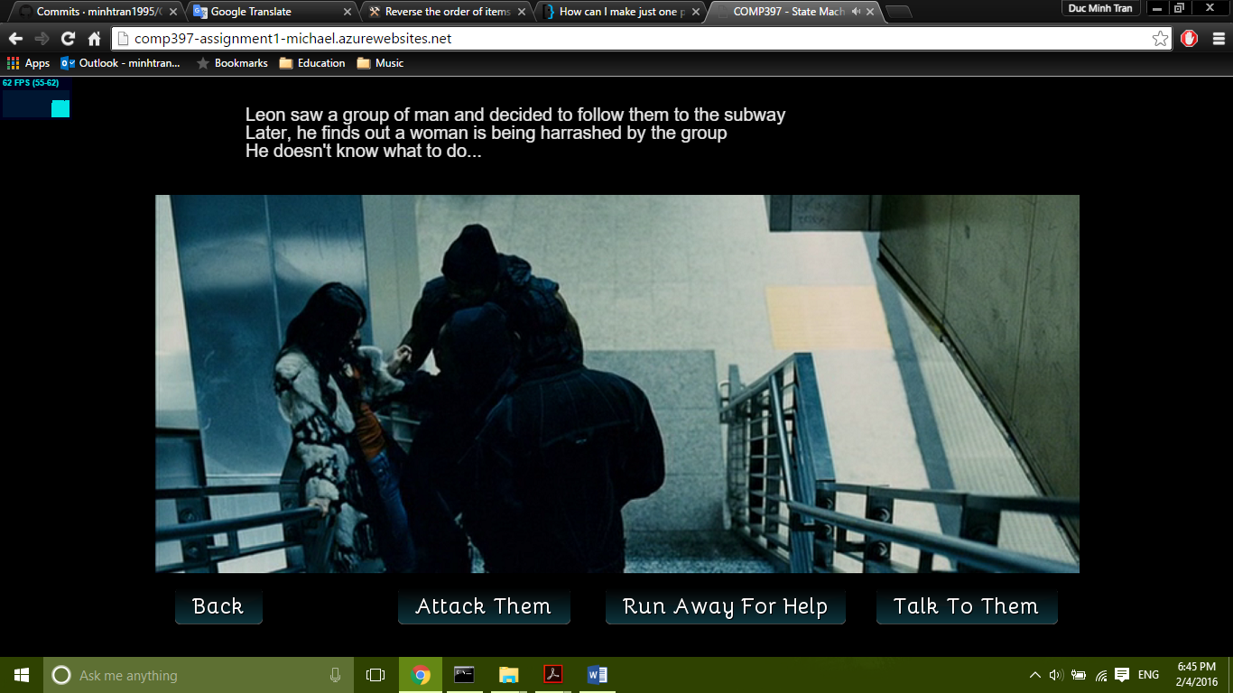

This Scene show a dilemma with multiple decision, it also allows user to go back to previous scene

# Menu and Screen Descriptions

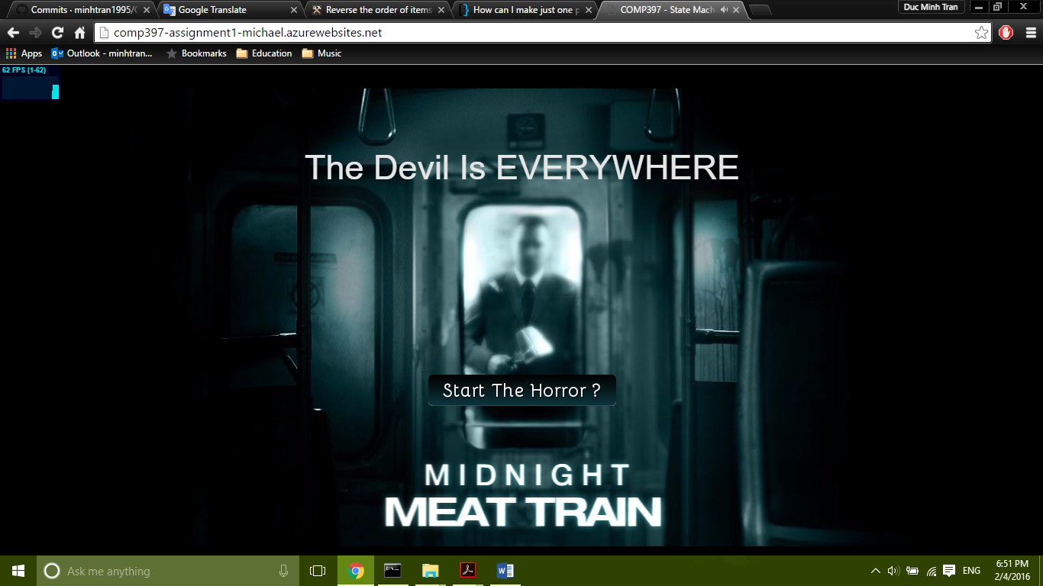

The main menu game has only one button, allowing user to start the game. It design also gives player a main theme of the game

# Game World

The game world/theme is mainly about the underground subway system and some of the situations that could happen there.

# Levels

N/A

# Characters

A young photographer named Leon, who is obsessed with the dark matter

# Non-player Characters

N/A

# Enemies

N/A

# Weapons

N/A

# Items

N/A

# Abilities

N/A

# Vehicles

N/A

# Script

N/A

# Scoring

N/A

# Puzzles/Mini-games

N/A

# Bonuses

N/A

# Cheat Codes

N/A

# Art / Multimedia Index

I have been adding multiple background images and sounds to simulate the dark theme of the game

# Design Notes

(Include additional design notes here)

# Future Features

* Adding more scenes
* More sound Effect
* Work more on scenes Design